Lab Exercise 8
Setting up Maven Build Job in Jenkins

Objective: To set up Maven build job in Jenkins for automating the build process, enabling continuous integration to enhance the software development lifecycle

Tools required: Jenkins

Prerequisites: You need to have a Jenkins up and running.

Steps to be followed:
- Log in to Jenkins CI tool and configure Maven freestyle job

Step 1: Log in to Jenkins CI tool and configure Maven freestyle job

- Log in to Jenkins using your credentials

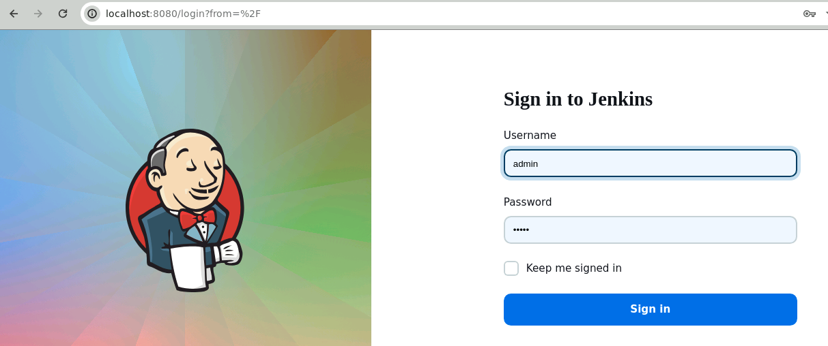
Note: The credentials for accessing Jenkins in the lab are Username: admin and Password: admin.

- In the Jenkins dashboard, click on New Item

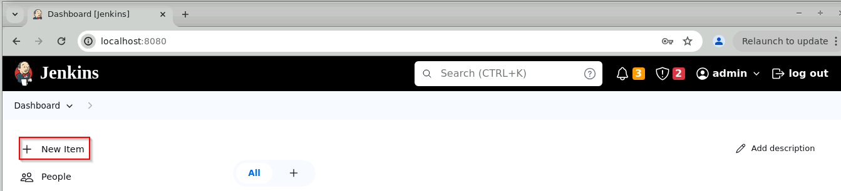

- Select the Freestyle project while creating a Jenkins job, provide a custom job name, and click on OK

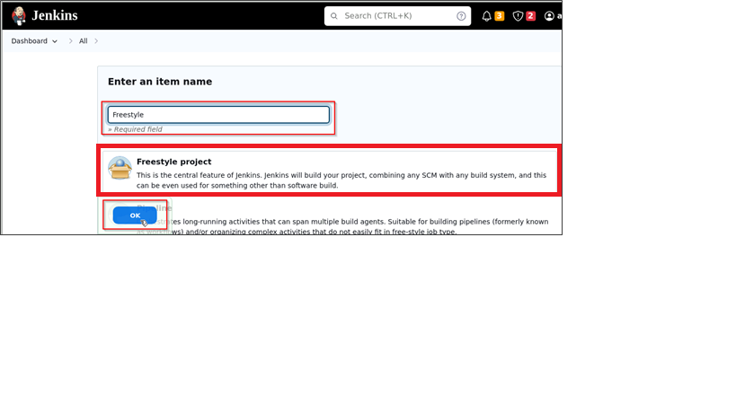

- Now, in the Configure page, navigate to Source Code Management in the left navigation bar, select Git, and then provide the Git repository URL

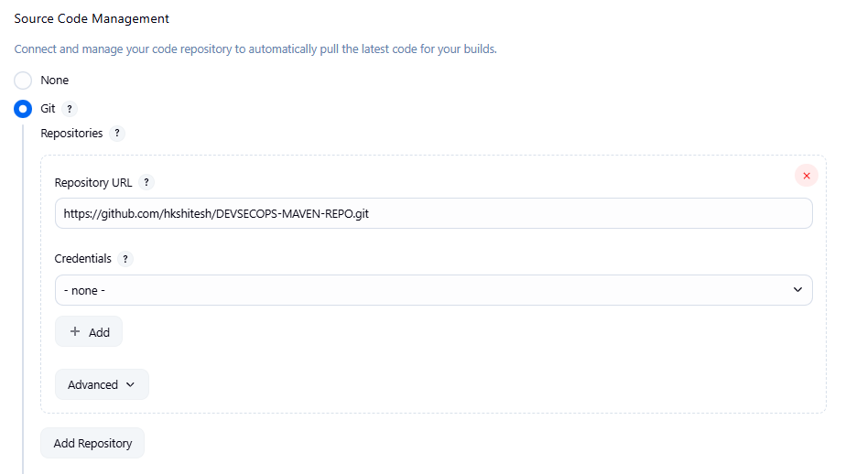
Note: Here, the repository URL is https://github.com/hkshitesh/DEVSECOPS-MAVEN-REPO.git.

Output:-

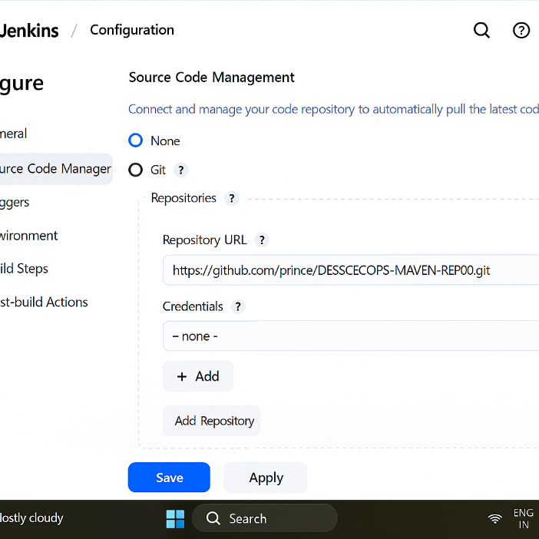

- Now, navigate to Build Steps, click on Add build step, and then select the option Invoke top-level Maven targets

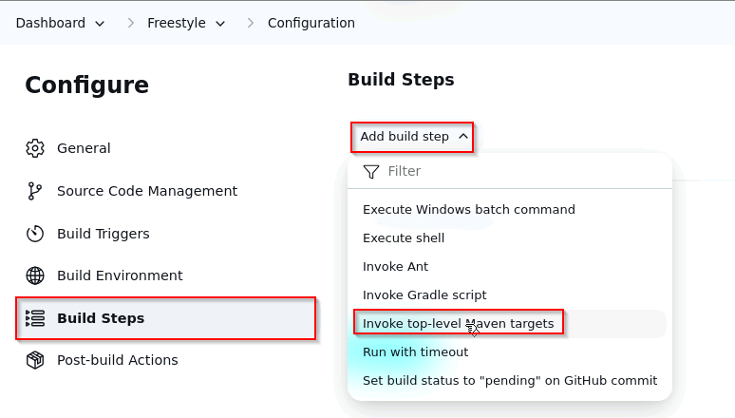

Output:-

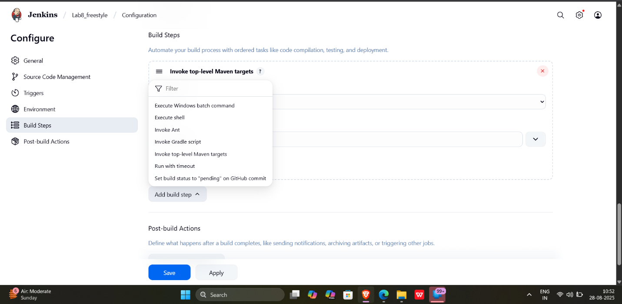

- Provide clean install under Goals section and then click on Save

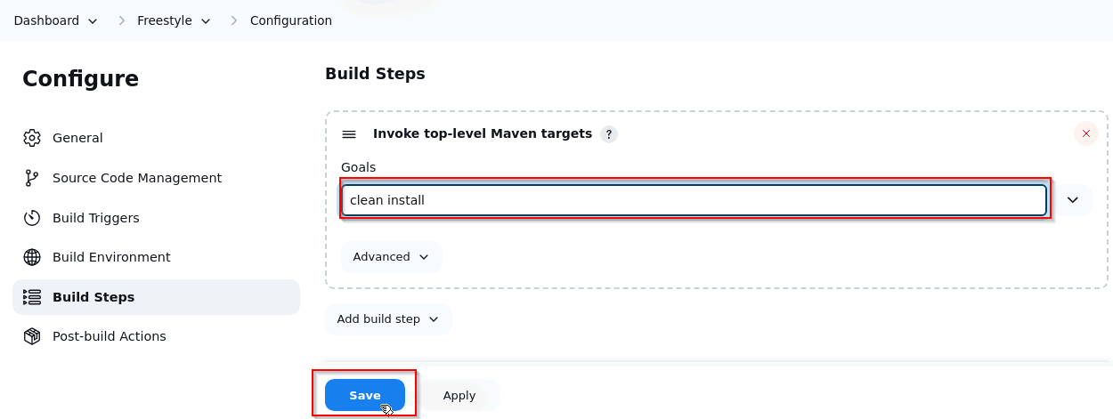

Output:-

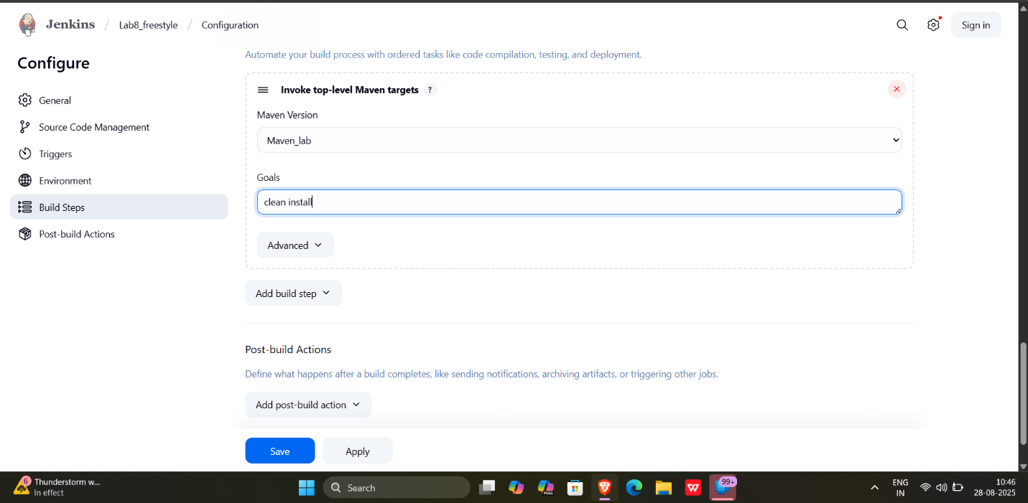

- You will be navigated to the project after clicking on Save. Now, click on Build Now to initiate a new build, and the build logs will display the progress of the build process.

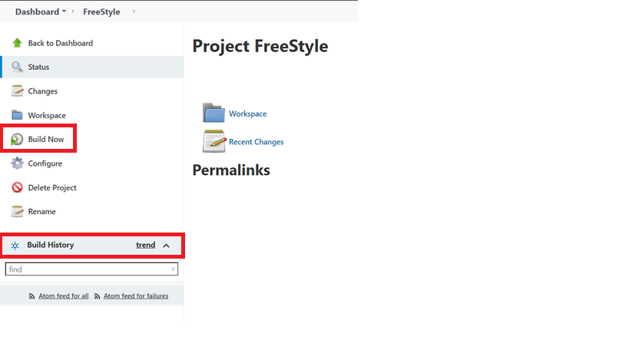

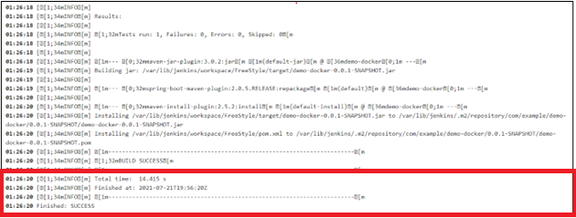

Output:-

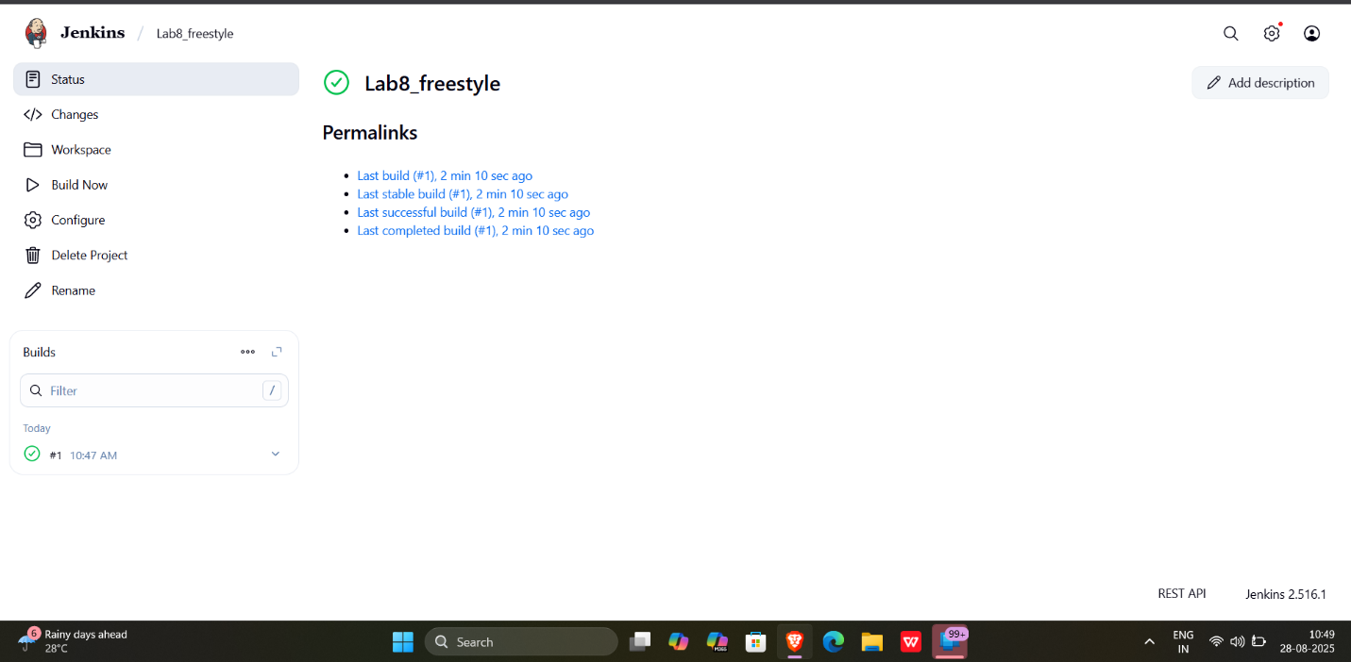

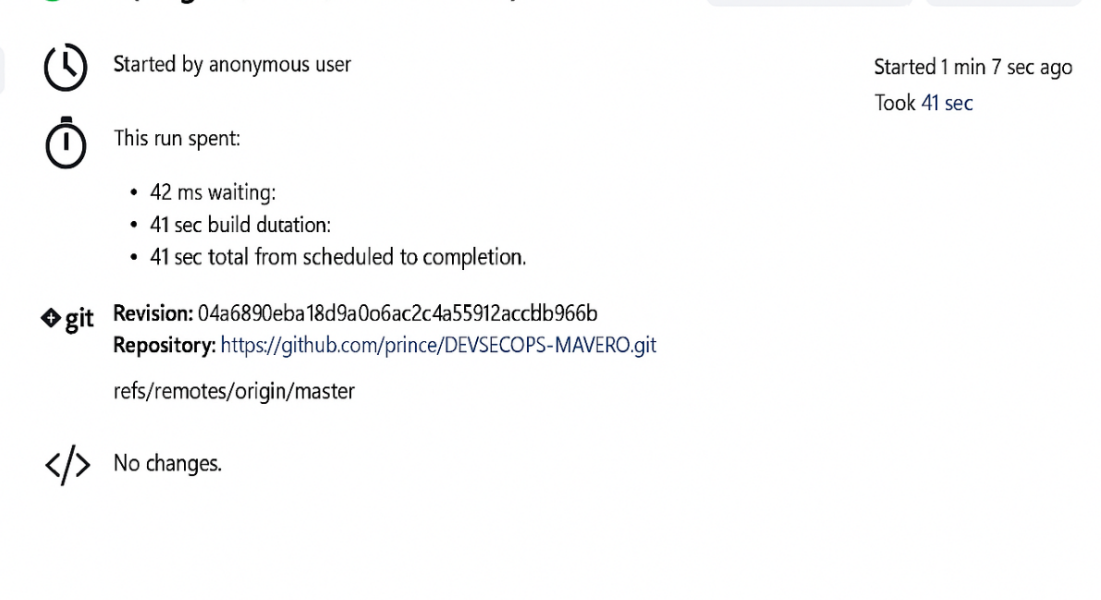

You can see that the build is configured successfully.

By following these steps, you have successfully set up Maven build job in Jenkins for automating the build process, enabling continuous integration to enhance the software development lifecycle.

